Exercise 1 Look and write :
teacher | builder | student | server | vet

 | 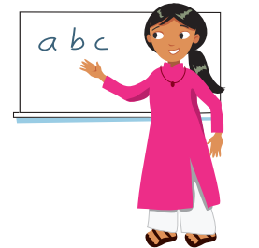 |  |  | 
……………………. | ……………………. | ………………… | ………………….. | …………………….
Exercise 2 Look at the picture and tick () or cross ()

a) They are students. b) They are servers. c ) They are teachers.


d) They are vets. e) They are servers. f) They are builders

Exercise 3. Look at the pictures and write

Yes , they are | No , they aren’t.


- Are they vets ? | - Are they teachers ? | - Are they builders ?
……………………………………. | ……………………………………. | …………………………………….

- Are they servers ? | - Are they students ? | - Are they vets ?
……………………………………. | ……………………………………. | …………………………………….

Exercise 4. Look and write :

She | He | They

a) ……….. is a vet. b) ……….. are servers. c) ……….. is a student.

d) ……….. is a builder. e) ……….. is a teacher. f) ……….. are teachers .

